Introduction
The SFTP protocol is used to connect to the data exchange service. It operates on top of the SSH protocol, a login + secret key pair is used for authorization.
To get access to the service, you need to generate a key, the public part of the key must be sent to your supervising manager in the TransContainer, in turn, the manager must send an Application to the Service Desk for the “OS and DBMS Support” command, which must specify the name of the depot and the public key.
Connection Settings
Protocol: SFTP
Server: trcont1.edifact.ru
Port: 22
Username: Your login issued by your manager
Path to the folder to data transfer: /files
Key Generation in Windows OS
To generate a key, you need to download and install the full PuTTY package (https://www.chiark.greenend.org.uk/~sgtatham/putty/latest.html)
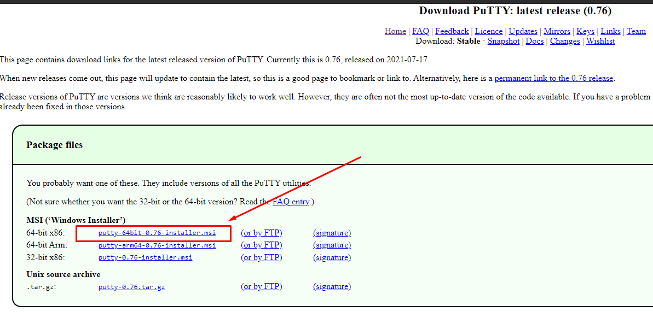
Install the entire contents of the package.
Run puttygen.exe (default path "C:\Program Files\PuTTY\puttygen.exe")
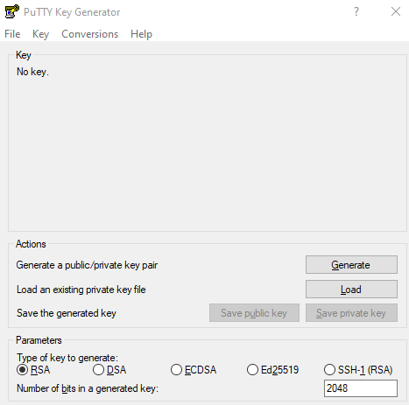

Optimal Security Settings:
Type of Generated Key: ECDSA
Key Length: 384 or 521
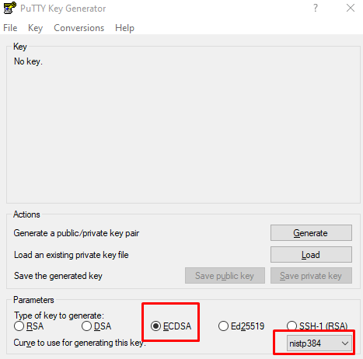

Click the Generate button. To fill in the field, you need to rotate the mouse until the progress bar is completely filled

As a result, we get the Generated Key:
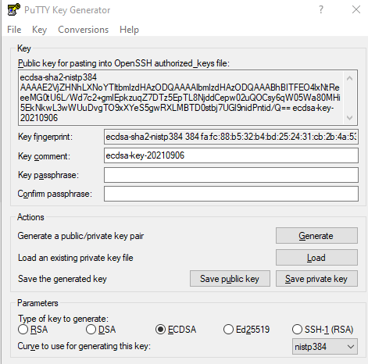
You may set a password to ensure protection.
To get access, you need to send to your manager all the text from the field
Public key for pasting into OpenSSH authorized_keys file
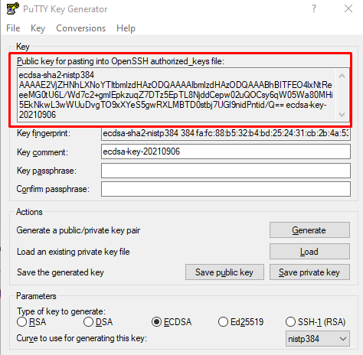
Save the received key by clicking on the Save private key button
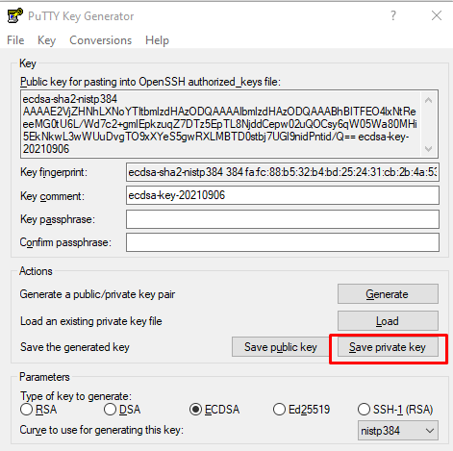
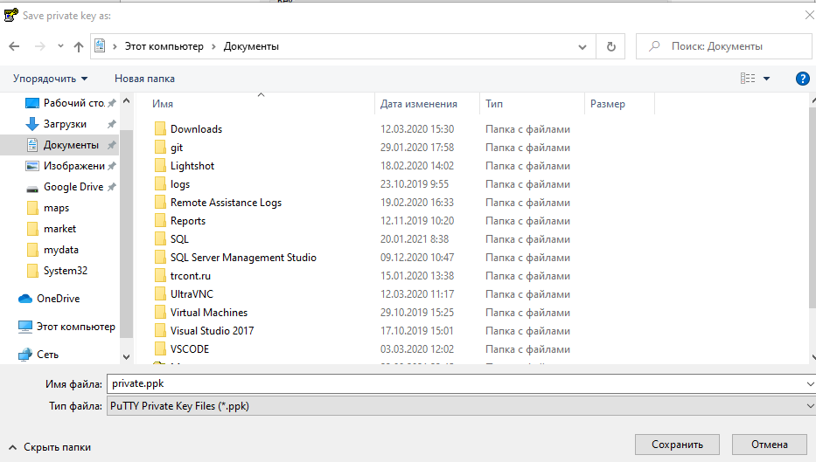

Connecting from Windows OS
To connect to the server, you need to install the WinSCP software (https://winscp.net/eng/download.php)
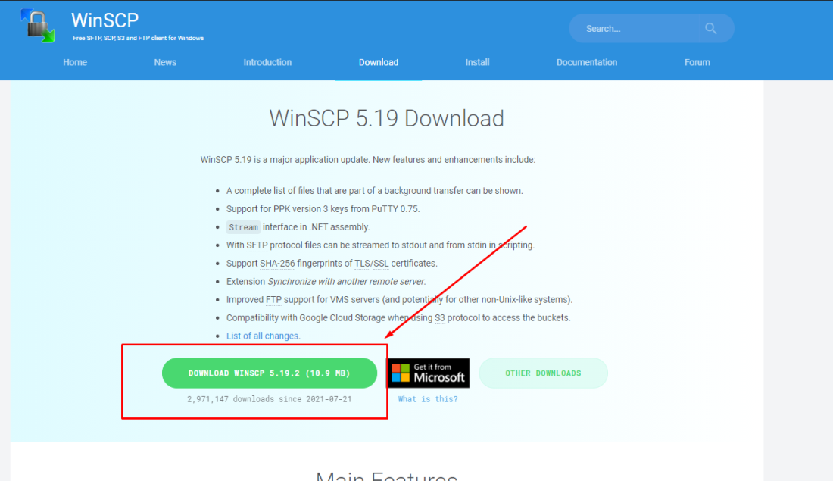

You need to run pagent (included in the PuTTY package) to connect. It is located in the tray
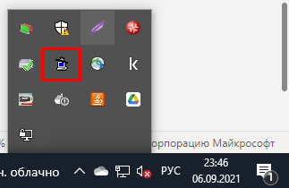

Add the key generated in the previous step in the window
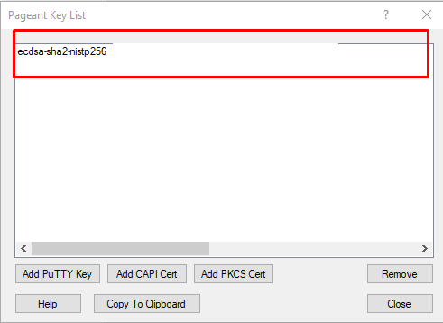

Run WinSCP
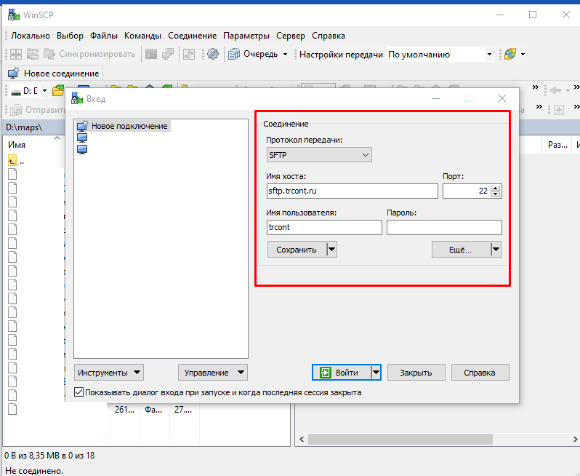

Click Enter
In the left window you will see the “Files” folder
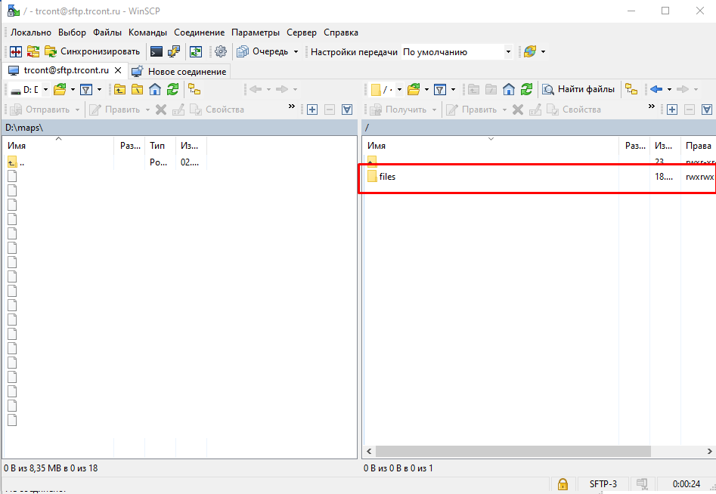
All documents for exchange must be placed in it, after copying and updating the contents of the directory, the files will disappear, this indicates a successful data transfer.

Key Generation in Linux OS (MAC, Unix, etc)
ssh-keygen utility: which is included in the openssh-client package.
To generate a key of the required strength, run the command under the user with whom you are going to transfer data.
ssh-keygen -t ecdsa -b 521

